Outdoor visit to Mary’s Pillar
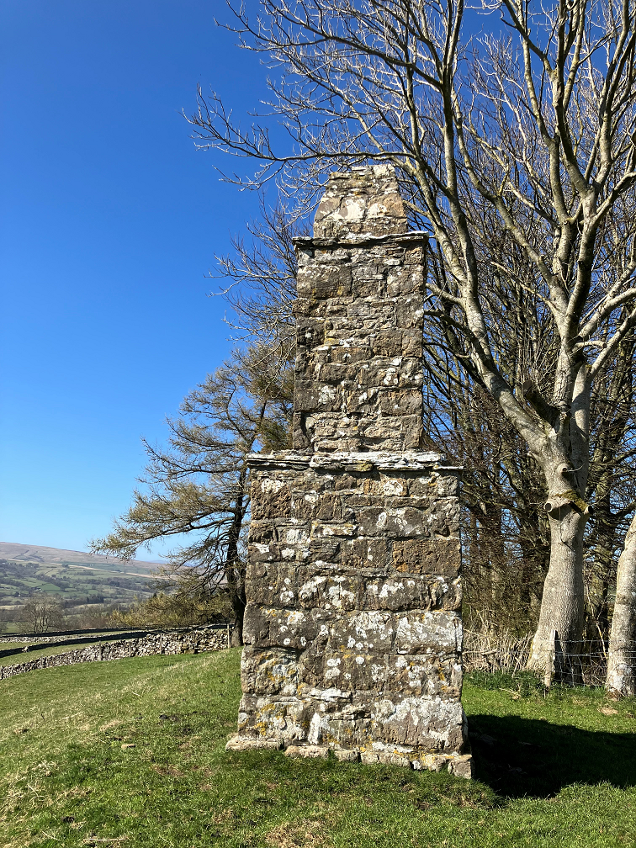
Situated close to the Bampton to Shap Road near Rosgill Head led by
Nick Lindwall
Tuesday 6th May
6pm
Meet at Bampton Memorial Hall for car sharing at 5:45pm; park near Lake View where road widens.
All Welcome
Lizzie and Nick Lindwall kindly invite for a reviving cup of tea!

